**Specification Document**

**Team Name-** Parallax **Date-** 19 Sep. 2023

**Project Name-**

**Project Purpose:**

A day planner is a crucial tool in our fast-paced world, helping people navigate their daily tasks, set priorities, and make the most of their time. We are developing this day planner because we understand the increasing need for a digital solution that not only keeps individuals organized but also empowers them to reach their full potential. Our ultimate goal is to create a user-friendly day planner application that simplifies the complex task of managing time.

We want to help users achieve their goals, boost their productivity, and lead more fulfilling lives. Our aim is to become the preferred choice for those looking to take control of their schedules and find the balance they need in today's hectic environment.

**A sample daily routine for using a day planner:**

1. In the morning, take a few minutes to review your planner for the day. This will help you get a sense of what you need to accomplish and how much time you have available.
2. Start by working on your most important and urgent tasks. If you have a lot of tasks to complete, break them down into smaller, more manageable steps.
3. Take breaks throughout the day to avoid burnout. Get up and move around, or take a few minutes to relax and clear your head.
4. At the end of the day, review your planner to see what you accomplished and what tasks still need to be completed. If you didn't get everything done, don't beat yourself up. Just pick up where you left off the next day.

**Project Scope:**

1. Registration and login for single-user

* Registration: Users can create personal accounts by providing their name, email, and password.
* Login: Registered individuals can access the application using their credentials, granting them access to it

2. Task Adding- User can add Personal, work miscellaneous tasks in list.

* Task Adding: Users can input and categorize tasks, including personal, work-related, and miscellaneous, creating a comprehensive task list.
* Category Organization: The system allows users to organize tasks into different categories for better management, ensuring a clear distinction between personal, work, and miscellaneous tasks.

3. Adding notes and links to tasks for revision.

* Note and Link Integration: Users can enhance task details by attaching notes and relevant web links, facilitating comprehensive task management.
* Revision Support: This feature enables users to create a rich context for each task, making it easier to review and revise tasks effectively by providing additional information and references.

4. Adding a progress bar to track progress.

* Progress Tracking: Users can monitor task completion with a visual progress bar, providing a clear overview of how much of a task or project has been accomplished.
* Real-Time Updates: The progress bar dynamically updates as users mark tasks as complete, helping them stay informed about their ongoing progress and remaining work.

5. Interface for Tasks- All tasks, weekly tasks and daily tasks.

* Task Interfaces: The application provides distinct interfaces for various task views, including an "All Tasks" view to see a comprehensive task list, a "Weekly Tasks" view to focus on tasks for the week, and a "Daily Tasks" view for a detailed daily task agenda.
* Efficient Navigation: Users can easily switch between these interfaces to manage their tasks effectively, depending on their immediate needs and preferences.

6. Calendar integration for meeting and day planning.

* Calendar Integration: The application seamlessly connects with users' calendars, allowing them to schedule meetings, appointments, and events within their day planner.
* Efficient Planning: Users can efficiently plan their days by visualizing their tasks alongside scheduled meetings and events, ensuring a well-balanced and organized daily schedule.

7. Adding weather forecasts for planning outdoor activities.

* Weather Integration: The application incorporates real-time weather forecasts, allowing users to check weather conditions before scheduling outdoor activities.
* Enhanced Planning: By providing accurate weather information, users can make informed decisions about when to plan outdoor tasks and events, ensuring they align with favorable weather conditions for a more enjoyable experience.

8. Prioritizing tasks.

* Task Prioritization: Users can assign priority levels to tasks, helping them distinguish between urgent and less important tasks.
* Enhanced Productivity: This feature enables users to tackle high-priority tasks first, ensuring they focus on what matters most and optimize their productivity.

9. Searching and filtering out tasks.

* Task Search: Users can quickly find specific tasks by entering keywords or phrases in the search bar, facilitating easy retrieval of tasks from their lists.
* Filtering Options: The application allows users to filter tasks based on various criteria, such as due date, priority, or category, enabling them to refine task lists and focus on specific subsets of their tasks.

10. Adding Recurring tasks like bill payment.

* Recurring Tasks: Users can set up tasks that repeat at specified intervals, such as bill payments or weekly meetings, eliminating the need to manually recreate these tasks.
* Automation and Reminders: The system automates the creation of recurring tasks and sends reminders, ensuring users don't forget important, repetitive obligations, enhancing overall task management efficiency.

11. Reminders through notifications and emails.

* Notification Reminders: The system sends timely notifications to users' devices, such as mobile phones or desktops, to remind them of upcoming tasks or events.
* Email Notifications: Additionally, users can opt to receive reminder notifications via email, ensuring they stay informed about their scheduled activities even when they are not actively using the application.

12. Tracking for daily expenses.

* Expense Tracking: Users can record and categorize their daily expenses, allowing them to keep a detailed account of their financial transactions.
* Financial Insights: The system may generate reports or summaries of daily expenses, providing users with insights into their spending habits and helping them make informed financial decisions.

13. Integrating Gmail for reminders.

* Gmail Integration: The application offers the capability to link and sync with a user's Gmail account.
* Email Management: This integration enables users to access their Gmail messages, contacts, and meetings directly within the application, streamlining email management and enhancing productivity.

14. Color Themes:

* Users can customize the application's appearance by selecting from a range of color themes, allowing them to personalize the interface to suit their preferences and make it visually appealing.
* Labels and Icons: The application utilizes labels and icons for tasks and categories, enhancing user-friendliness by providing visual cues and making it easier for users to quickly identify and interact with different elements within the app.

**Target Audience:**

The user of this app is typically any individual who wants to organize and manage their daily schedule, events, tasks, appointments, and other activities.

Our day planner application aims to empower this audience by providing them with a user-friendly and efficient platform to elevate their productivity and time management skills to new heights.

**User Actions:**

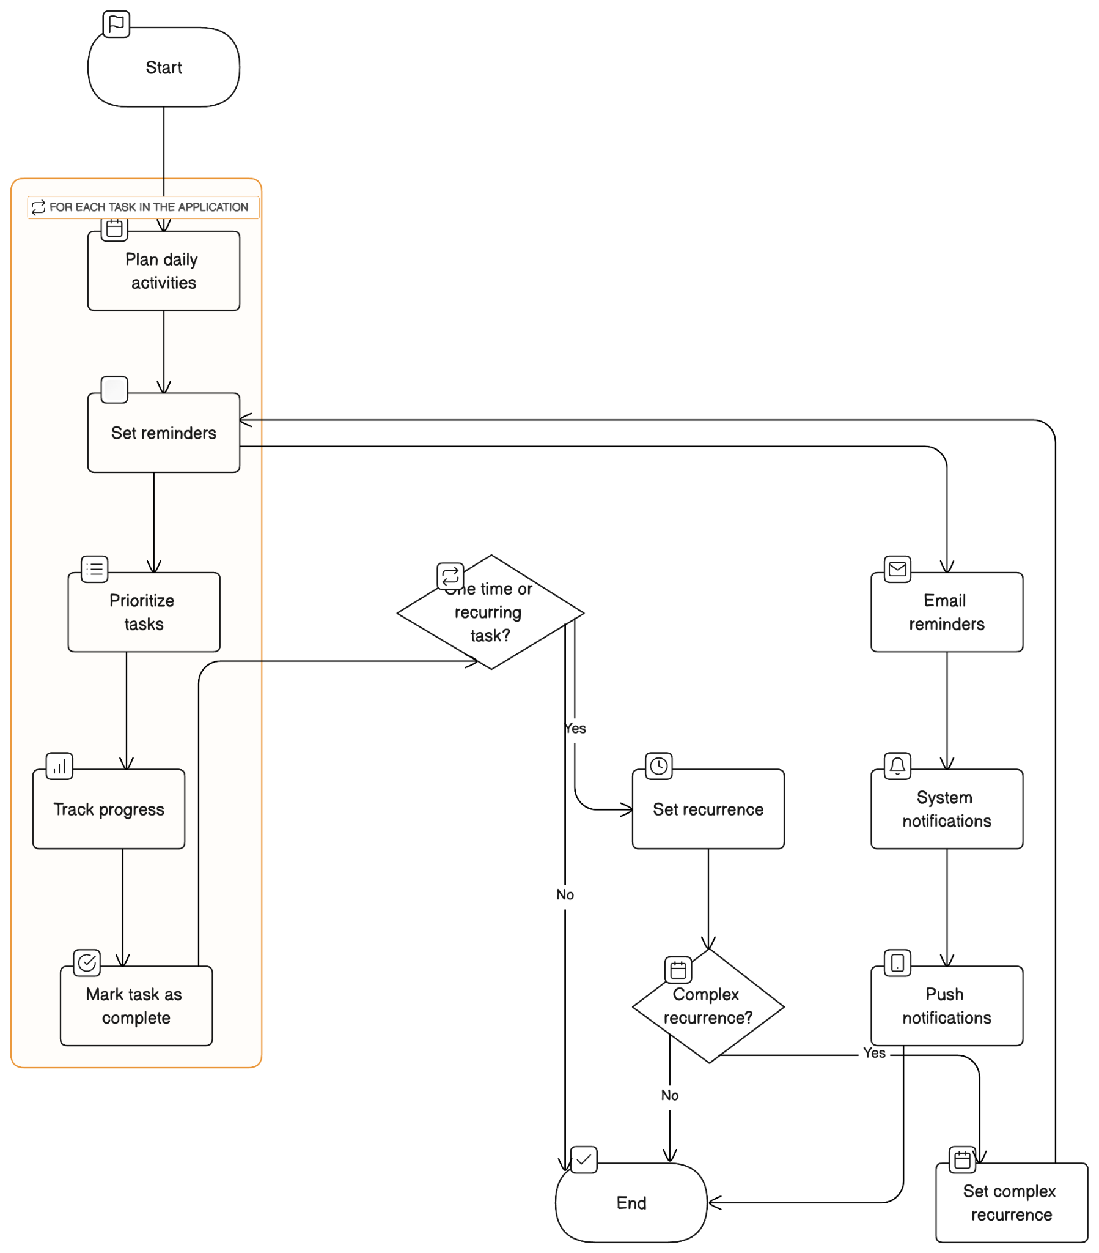

**Requirement Analysis:**

**Functional Requirements**

* Create and manage events: Users should be able to create and manage events, including setting the event name, start and end times, location, and description.
* View events: Users should be able to view their events in a list or calendar view.
* Receive alerts and reminders: Users should be able to set alerts and reminders for upcoming events.
* Share events: Users should be able to share events with other users via email, messaging, or social media.
* Integrate with other calendars and applications: The day planner application should be able to integrate with other calendars and applications, such as Google Calendar and Outlook, gmail.

**External interface Specifications**

1. Firebase Integration :-

Firebase Authentication:- Specify how users interact with Firebase Authentication for sign-up, login, and account management.

Firebase Realtime Database or Firestore: - Document the data structure and data flow between your app and Firebase's database services.

Firebase Cloud Functions: - Describe the functions you've deployed to Firebase and how the app communicates with them.

Firebase Cloud Storage: -Explain how the app stores and retrieves files and media in Firebase Cloud Storage.

1. Google Cloud Integration

Google Cloud APIs: If your app uses specific Google Cloud APIs (e.g., Google Calendar API for calendar integration), provide details on how the app accesses and utilizes these APIs.

Google Cloud Functions: Specify the Google Cloud Functions or serverless components used and how they interact with the app.

1. Google calendar Integration

Describe how your app uses the Google Calendar API and how it interacts with your app to manage events, appointments, and schedules.

**Technical Specifications**

For Android devices:

Operating System: Android 4.1 or newer(but it's better to use a more recent version)

Processor: Modern ARM or x86 one with at least 1 GHz.

Screen: It's better if the phone has a 720p (HD) or better screen for a nicer view.

**Sample User Examples:**

* As a user, I want to be able to create an event for a doctor's appointment so that I don't forget.
* As a user, I want to be able to set a reminder for an upcoming meeting so that I arrive on time.
* As a user, I want to be able to share my event schedule with my family and friends so that they know when I'm available.
* As a user, I want to be able to view my events in a calendar view so that I can see what I have planned for the week.
* As a user, I want to be able to integrate my day planner with my Google Calendar so that I have all of my events in one place.

**Use Cases:**

* A student uses the day planner application to create and manage their class schedule, study sessions, and extracurricular activities.
* A business professional uses the day planner application to create and manage their meeting schedule, appointments, and deadlines.
* A parent uses the day planner application to create and manage their child's activities, appointments, and medical visits.